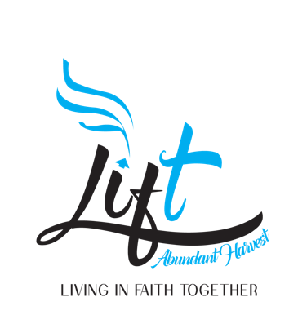
Boland Family Scholarship
Mission
The purpose of the Boland Family Scholarship is to provide scholarships to college-bound high school students who attend Abundant Harvest Lift Church and live in the community. The Boland family believes a college education will not only transform lives of students but also provide advanced opportunities for personal growth, career options, creation of generational wealth and much more. The Scholarship seeks to minimize the financial impact of a college education. Investing in our future leaders allows them to be impactful in their communities, helps to bridge social and economic gaps and create a pathway to upward mobility.

Eligibility Criteria
· High School Senior or graduate who plans to enroll in a full-time undergraduate study program at an accredited two-year or four-year college or university for the entire upcoming academic year.
· Have a minimum grade point average of 3.0 on a 4.0 scale (or equivalent)
Applicant Checklist
- Name, Address, Phone, Email and Names of Parents or Legal Guardian
- Must be a citizen or legal permanent resident of U.S.
- Complete Application and Submit by July 15th.
- High School Students - Official Transcript
- (2) Academic Letters of recommendation from teachers
Essay Question (500 words)
Applicant will complete one essay answering the following question:

- Describe a person you admire and why?
- Share your educational aspirations?
- What role has Christianity played in your life and relationships?
- What is the greatest obstacle you have faced and what did you learn from it or how did you overcome it?
- Please share your desired field of study.

Close with providing us with the college you are planning to attend and or college acceptance letter. If accepted, you will be required to show confirm college acceptance.

Awards for (Community College and Universities Varies)
· Awards are in the amount of $2,500 and $5000.
Email Essay to: Liftpeople411@gmail.com
Student Recipients: Parents and or students will be notified by a phone.
Parents Matching Scholarship Challenge
We encourage family and friends to donate and support the mission of Boland Family Scholarship and Abundant Harvest Lift by helping make a difference in more young people’s lives as we purpose to build generational legacy. If you can match any of the scholarship amounts for us to help more of our youth.

You Choose: $500.00; $1,000.00, $2,500.00 or $5,000 or more to help us impact young people’s lives for the next four years!

All Contributions are Tax Deductible!

(Copy and Paste Link in Browser to Sow Your Gift of Love)
https://tithe.ly/give_new/www/#/tithely/give-one-time/254163
Make Note: Donations is for Lift/Boland Scholarship

